10 Things You Should Know About Dry Shippers Before Shipping High Value Biologics

As the biotech world has grown, the need to ship high value cell- and tissue-based materials has increased exponentially. An invaluable tool in the quest to move material in a safe and effective manner is the dry shipper and its counterpart, the data logger. While the dry shipper is key to successfully shipping materials both internationally and domestically, misconceptions about the workings of these devices can jeopardize your success (read more about this in my other cell therapy blog - "Commercially Successful Cell Therapies: Navigating the Ultra Cold Chain Minefield").
This will be a two-part blog that follows the most common misconceptions I have encountered among users of dry shippers. While this is not a complete guide, my hope is that these 10 tips will illustrate the questions you need to ask before you ship high value biologics with dry shippers.
1. Not all dry shippers are created equal
There are wide variations in dry shippers with regard to size and temperature (static) hold times and you should select the shipper that best fits your application. Sizes can range from space for a dozen vials or canes to shippers that can hold 25,000 vials. Temperature hold times can vary from a few days to more than two weeks. Variations also exist in how well they hold temperature under different environmental and handling conditions.
2. Significant variations can occur among dry shippers of the same make and model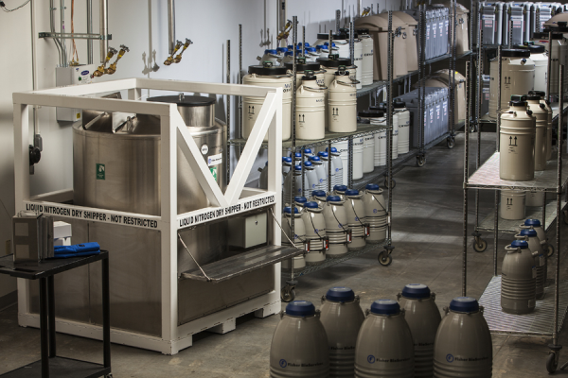
The manufacturers' spec is no guarantee of a specific hold time. While some units are better than others, even among the best, variations of up to 40% are not uncommon. This is particularly important if you plan to use the dewar for temporary storage. In addition, in shipping a dewar internationally, you should anticipate a complicated customs process or an unusually long transit time. Imagine a scenario in which you accounted for eight days maximum!
3. Data loggers will reduce static hold over time
Data loggers allow us to create a record of the internal temperature of the dry shipper while in transit. In addition, they set acceptable temperature windows that will alert the recipient if a temperature excursion occurred during the shipping process. While data loggers are an invaluable tool in tracking and documenting temperature, attaching one to a dry-shipper will invariably reduce static hold times. The logger and probe set create a “heat wick” that draws heat into the interior of the dry shipper, reducing the static hold time. The extent of this wicking effect depends on the logger and probe configuration.
4. Get usable results by evaluating the location of the data logger on a dry-shipper and how it is secured and protected
Data loggers are an aftermarket addition and the quality of their performance is contingent on how they are installed and protected during transit. Not all models work well in the same locations so pick the dry shipper and data logger combination that is best for your particular situation.
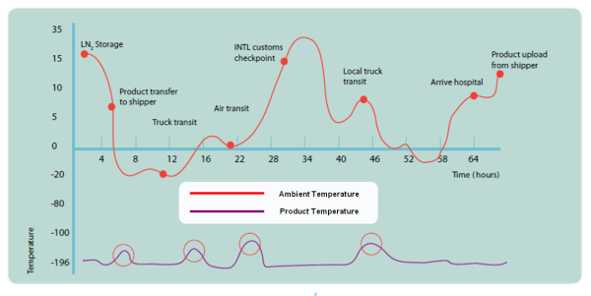
5. The ability of dry shippers to hold temperature decreases over time
While dry-shippers have no moving parts, they do have two components that deteriorate over time. The first is the vacuum between the inner and outer vessel. This vacuum is critical and diminishes with use. The other element is the absorbent material that traps the liquid nitrogen. A simple 24-hour evaporation test will allow you to determine if there has been significant deterioration in either or both.
The importance of the temperature monitoring equipment and evaluating the size and static hold time of a dry shipper cannot be understated (learn more about ultra cold chain and logistical challenges at my upcoming webinar). Companies must ship materials the right way to ensure compliance with FDA requirements, patient safety, and success in their research. Stay tuned for Part II of this blog post that will cover the remaining five tips. What problems have you encountered when shipping high value biologics? Do you agree with these five tips?
- Orientation matters
While most organizations test their dry shippers before using them, the tests tend to be in an upright position with little or no movement. In transit the dewar can assume many different orientations ranging from upright to upside down and everything in between. This has a major impact on static hold time. A dry shipper on its side can lose as much as 60% of its hold time in a few hours. A large dry shipper transported upside down for even a few hours can go from days of hold time to hours.


7. There are no style points in the shipping business
Moving material by air or truck is about speed and efficiency not handling. It does not matter which carrier or “white glove” service you use, the number of labels and warnings you affix or the assurances you receive. It does not matter if the dewar will be kept upright but how long will it be on its side or upside down.

- A good shipping rack is a great investment
In the struggle to keep material cold you must insure the material is not damaged in transit. Whether you are shipping vials, bags or pre-fills material chilled to cryogenic temperatures is vulnerable. A good solution involves minimizing movement during shipment and a great solution involves eliminating movement. The best way to do that is to use a custom rack.

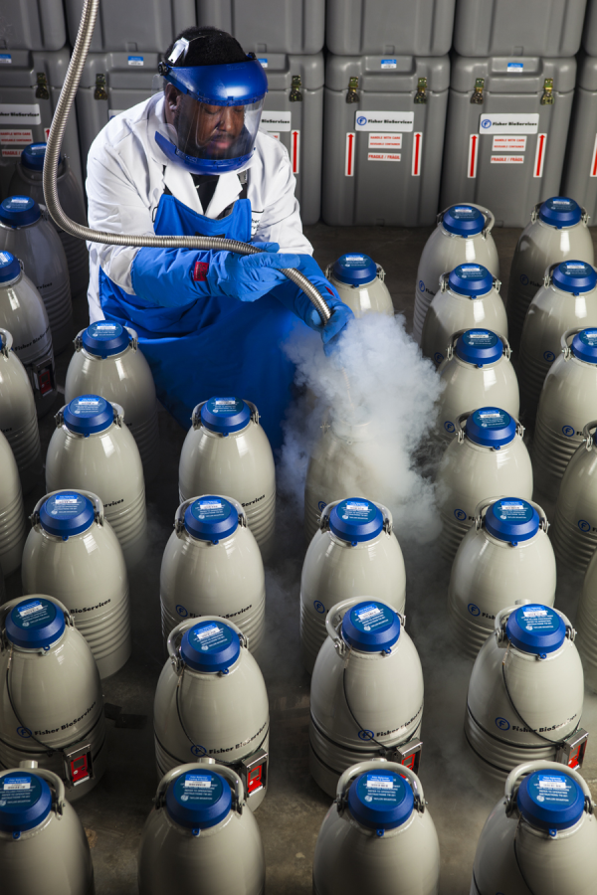
- Avoid temperature excursions when shipping by air
Because nitrogen vents in small amounts from a dry-shipper in cannot be a sealed unit. Because it is not a sealed unit it is subject to in-gassing during cabin pressurization and depressurization. This creates two problems: First, you can jeopardize the integrity of the material being shipped or second, you can get temperature excursion alarms from your data logger. The solution is proper payload location, proper probe location and proper baffling and packaging.
- If you are not familiar with shipping at cryogenic temperatures contact a specialist
I do this for a living and I still learn something new every day. A ten minute phone conversation can save you a great deal pain and suffering not to mention time and cost. I hope you have found these tips of value. As the use of dry shipper increases the more knowledge you have, the better prepared you will be to face shipping challenges in the present and future. If you are seeking additional information about this topic, please checkout our ebooks on "Commercially Successful Therapies: Navigating the Ultra Cold Chain Distribution Minefield" and "Cold Chain Qualification: 5 Questions You Must Ask When Shipping Biologics". The first takes a look at the challenges in the storage and distribution of high value biologics and the second written by Praveen Bezwada-Joseph, Director of Validation Services, discusses the need and requirements in qualifying shipping solutionsfor all temperature ranges. If you have any questions pertaining to this topic feel free to email me.

